Description of dike models developed by M. Townsend summer 2024 to simulate dike growth in the basement beneath a surface load

Big-picture overview of this work:
These are models that advance on the dike-chamber model of Segall et al. (2001) to consider how gradients in external stress arising from the load of a volcano and/or the load of an ice sheet impact dike growth, geometry, and possible eruption locations. One big assumption is that the external stress perturbation is axisymmetric. There are a few variations of this model based on assumptions about dike geometry (whether it stays as an ellipsoid or whether the dike front migrates non-elliptically) and boundary conditions (constant influx at inlet vs. coupling with a depressurizing reservoir, either a fixed inlet location or a migrating inlet). What follows includes detailed descriptions of the math, definitions of variables, and location of codes for running the models.

Models described below:
- MODEL A1: ELLIPTICAL DIKE, MIGRATING INLET, COUPLING TO A DEFLATING RESERVOIR
- MODEL A2: ELLIPTICAL DIKE, MIGRATING INLET, CONSTANT INFLUX
- MODEL B: ELLIPTICAL DIKE, FIXED INLET, CONSTANT INFLUX
- MODEL C: NON-ELLIPTICAL DIKE, FIXED INLET, CONSTANT EXCESS PRESSURE

MODEL A1: ELLIPTICAL DIKE, MIGRATING INLET, COUPLING TO A DEFLATING RESERVOIR

Code location:

/Users/mtownse4/Dropbox (Lehigh University)/All Dropbox Files/Matlab/Volcano Loading/DIKE MODEL WORK SUMMER 2024/MODEL A1: ELLIPTICAL DIKE MIGRATING INJECTION COUPLED TO RESERVOIR

Description:

This dike model is based on mass conservation between an overpressured chamber and a dike, as in Segall et al. (2001). I assumed the dike is vertically oriented with a fixed strike and grows as an ellipsoid with vertical half-height $b$, horizontal half-length $a$, and thickness $δ$ (Fig 1). The velocity of the dike tipline is computed at four locations: the uppermost edge (directly above the point of injection), the lowermost edge (directly below the point of injection), and the lateral edges along the centerline of the dike. Because the dike may grow faster in the vertical or horizontal directions it may not remain penny shaped. In addition, the upper and lower tips may not grow at the same rate, so the center of the dike may shift over time. Confining stress acting on the dike changes accordingly if the dike centroid position shifts. In some cases, the lower tip begins to migrate up past the point of injection, but I assume that the dike and chamber remain hydraulically connected with a hydraulic “connectivity” that evolves as the distance between the chamber and dike center evolve. The flow rate of magma into the dike is proportional to this connectivity and the pressure difference between the chamber and the dike. Dike growth stops when one of the following conditions are met: 1) the chamber depressurizes below a critical amount; 2) the chamber and dike pressure re-equilibrate (no pressure difference to drive flow); 3) the upper position of the dike reaches the base of the volcanic edifice (I do not here consider propagation into the edifice but assume that if it makes it that far it can erupt).

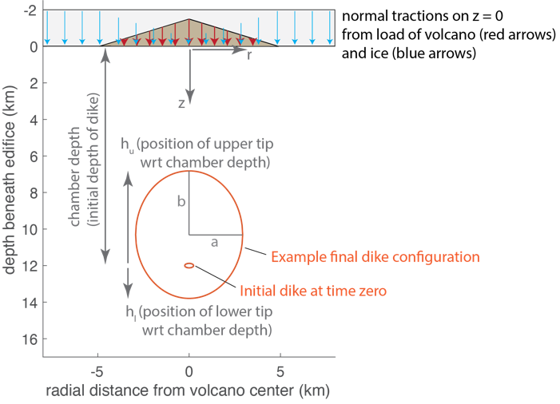
Schematic of Model A: blue and red arrows represent normal tractions acting on the crust as a result of the ice and volcano load; red ellipses are examples of initial and final dike configurations, with arrows and symbols defining the key variables.

Equations:

We idealize the dike shape as a vertically oriented ellipsoid with horizontal half-length $a$, vertical half-length $b$, and maximum thickness $δ$, for a total volume $V_{d}=\frac{2π}{3}abδ$. The rate of change in dike volume is thus

$\frac{dV_{d}}{dt}=\frac{2π}{3}\left[bδ\frac{da}{dt}+aδ\frac{db}{dt}+ab\frac{dδ}{dt}\right]$ EQ 1

The dike is fed by a source reservoir such that

$\frac{dV_{d}}{dt}=\frac{c}{ρ_{m}}\left(P_{c}-P_{d}\right)$ EQ 2

Where $P_{c}$ is pressure in the chamber, $P_{d}$ is pressure in the dike, $c$ is the hydraulic conductivity between the chamber and dike, and $ρ_{m}$ is magma density.

Let’s define $h_{u}$ as the position of the upper dike tip relative to the original injection depth, $d_{i}$, (positive up from the injection position), and $h_{l}$ as the position of the lower dike tip relative to the original injection depth (positive down from the injection position). We use $σ$ to represent the $σ_{θθ}$ component of stress within the crust, which is a sum of the lithostatic load and the perturbation to this from the load of the volcano and ice sheet.

Velocity of the upper dike tip:

$\frac{dh_{u}}{dt}≅\frac{δ^{2}}{3η}\left(\frac{ΔP_{d}}{b}+{\left.\frac{dσ}{dz}\right|}_{z={d_{i}-h}_{u}}-ρ_{m}g\right)$ EQ 3

Velocity of the lower dike tip:

$\frac{dh_{l}}{dt}≅\frac{δ^{2}}{3η}\left(\frac{ΔP_{d}}{b}-{\left.\frac{dσ}{dz}\right|}_{z={d_{i}+h}_{l}}+ρ_{m}g\right)$ EQ 4

where $η$ is the magma viscosity, and $ΔP_{d}$ is the overpressure at the dike inlet, defined as the difference between the absolute magma pressure at the dike inlet, $P_{d}$, and the confining stress at the dike inlet, $P_{con}$.

So the total vertical length of the fluid-filled portion of the dike is $h_{u}+h_{l}$. Then the rate of change in the vertical half-length becomes

$\frac{db}{dt}=\frac{1}{2}\left(\frac{{dh}_{u}}{dt}+\frac{{dh}_{l}}{dt}\right)$ EQ 5

The growth rate of the dike in horizontal half-length is

$\frac{da}{dt}≅\frac{δ^{2}}{3η}\left(\frac{ΔP_{d}}{a}+{\left.\frac{dσ}{dr}\right|}_{r=a}\right)$ EQ 6

We simplify $δ$ as the value of maximum opening at the center of an elliptical crack:

$δ=\frac{2b(1-ν)ΔP_{d}}{μE(k)}$ EQ 7

Where $ν$ and $μ$ are the Poisson’s ratio and shear modulus of the host crust, respectively, and $E(k)$ is the complete elliptic integral of the second kind with modulus $k=\sqrt{1-b^{2}/a^{2}}$.

Then

$\frac{dδ}{dt}=\frac{2(1-ν)}{μE}\left[ΔP_{d}\frac{db}{dt}+b\left(\frac{dP_{d}}{dt}-\frac{dP_{con}}{dt}\right)-\frac{b^{2}ΔP_{d}}{a^{3}k^{2}}\left(\frac{E-F}{E}\right)\left(b\frac{da}{dt}-a\frac{db}{dt}\right)\right]$ EQ 8

Where $F$ is the complete elliptic integral of the first kind with modulus $k$.

Substituting EQs 2, 7, and 8 into EQ 1 and letting $A=\left(\frac{E-F}{E}\right)\left(\frac{1}{a^{2}/b^{2}-1}\right)$ leads to an equation governing the evolution of absolute magma pressure at the dike inlet:

$\frac{dP_{d}}{dt}≅\frac{3μE\left(k\right)}{4π\left(1-ν\right)ab^{2}}\frac{c}{ρ_{m}}\left(P_{c}-P_{d}\right)-\left[1-A\right]\frac{ΔP_{d}}{a}\frac{da}{dt}-\left[2+A\right]\frac{ΔP_{d}}{b}\frac{db}{dt}+\frac{dP_{con}}{dt}$ EQ 9

As the dike grows, the position of the dike inlet moves up, and so the confining stress at the dike inlet changes as it moves through external stress gradients. The depth of the dike center at any given time $d_{c}=d_{i}-h_{u}+b$, and so the rate of change in confining stress at the dike center is:

$\frac{dP_{con}}{dt}=\frac{1}{2}\left(\frac{{dh}_{l}}{dt}-\frac{{dh}_{u}}{dt}\right){\left.\frac{dσ}{dz}\right|}_{z=d_{c}}$ EQ 10

Finally, the equation governing chamber overpressure is

$\frac{dΔP_{c}}{dt}=\frac{-c}{ρ_{m}V_{c}β_{c}}\left(ΔP_{c}-ΔP_{d}\right)$ EQ 11

Where $V_{c}$ is the volume of the chamber and $β_{c}$ is the effective compressibility of the chamber (sum of chamber and magma compressibility).

If any point along the upper edge of the dike intersects the bedrock surface (the cone surface), the dike is considered to erupt. At this time, the dike stops growing in the vertical direction, $\frac{dh_{u}}{dt}=0$, and the eruptive flux is taken into account in the mass balance so that EQ 9 becomes

$\frac{dP_{d}}{dt}≅\frac{3μE\left(k\right)}{4π\left(1-ν\right)ab^{2}}\left(\frac{c}{ρ_{m}}\left(P_{c}-P_{d}\right)-q_{erupt}\right)-\left[1-A\right]\frac{ΔP_{d}}{a}\frac{da}{dt}-\left[2+A\right]\frac{ΔP_{d}}{b}\frac{db}{dt}+\frac{dP_{con}}{dt}$ EQ 12

$q_{erupt}=\frac{waδ^{3}}{3η}\left(\frac{ΔP_{d}}{b}+{\left.\frac{dσ}{dz}\right|}_{z={d_{i}-h}_{u}}-ρ_{m}g\right)$ EQ 13

Where the length of the eruptive fissure is taken to be some fraction, $w$, of the dike half-breadth, $a$.

Then we have seven equations (3,4,5,6,9 or 12,10,11) for seven unknowns $h_{u}$, $h_{l}$, $a$, $b$, $P_{d}$, $P_{con}$, and $ΔP_{c}$.

Initial conditions:

$h_{u}\left(0\right)=b(0)$
$h_{l}\left(0\right)=b(0)$
$a\left(0\right)=0.02*d_{i}$
$b\left(0\right)=a\left(0\right)/2$
$P_{d}\left(0\right)=P_{con}\left(0\right)+ΔP_{c}\left(0\right)$
$$P_{con}\left(0\right)=σ(z=d_{i})$$
$$ΔP_{c}\left(0\right)=P_{crit}$$

Where $P_{crit}$ is some critical overpressure in the chamber to initiate a dike

Stopping conditions:

We stop the dike growth model when:
1) There is insufficient overpressure in chamber to drive flow into the dike
2) If insufficient overpressure in dike to keep it open
3) If insufficient pressure difference between chamber and dike to drive flow
and/or when the simulation reaches some maximum time.

MODEL A2: ELLIPTICAL DIKE, MIGRATING INLET, CONSTANT INFLUX

Code location:

/Users/mtownse4/Dropbox (Lehigh University)/All Dropbox Files/Matlab/Volcano Loading/DIKE MODEL WORK SUMMER 2024/MODEL A2: ELLIPTICAL DIKE MIGRATING INJECTION CONSTANT INFLUX

Description:

This is a slight variation of MODEL A1 (see above) to include a constant influx boundary condition.

To use a constant influx boundary condition with Model A (elliptical dike, migrating inlet), EQ 2 from above becomes $\frac{dV_{d}}{dt}=q_{in}$, so that EQ 12 becomes:

$\frac{dP_{d}}{dt}≅\frac{3μE\left(k\right)}{4π\left(1-ν\right)ab^{2}}\left(q_{in}-q_{erupt}\right)-\left[1-A\right]\frac{ΔP_{d}}{a}\frac{da}{dt}-\left[2+A\right]\frac{ΔP_{d}}{b}\frac{db}{dt}+\frac{dP_{con}}{dt}$ EQ 14

Where $q_{in}$ is the constant volumetric influx at the dike inlet, and $q_{erupt}$ is either zero if not erupting or given by equation 13 if erupting.

This version of the model is more applicable to the analog gelatin experiments.

Initial conditions:

$h_{u}\left(0\right)=b(0)$
$h_{l}\left(0\right)=b(0)$
$a\left(0\right)=0.02*d_{i}$
$b\left(0\right)=a\left(0\right)/2$
$P_{d}\left(0\right)=P_{con}\left(0\right)+ΔP_{d}\left(0\right)$
$$P_{con}\left(0\right)=σ(z=d_{i})$$

Where $ΔP_{d}\left(0\right)$ is some initial overpressure in the dike

Stopping conditions:

We stop the dike growth model when
- the final injection volume is reached
- when the dike breadth reaches some critical value
and/or when the simulation reaches some maximum time.

MODEL B: ELLIPTICAL DIKE, FIXED INLET, CONSTANT INFLUX

Code location:

/Users/mtownse4/Dropbox (Lehigh University)/All Dropbox Files/Matlab/Volcano Loading/DIKE MODEL WORK SUMMER 2024/MODEL B: ELLIPTICAL DIKE FIXED INJECTION CONSTANT Q

Description:

I assume the dike is vertically oriented with a fixed strike and grows as it is being supplied by fluid from a source with constant influx, with the injection point at a fixed location. The injection point is located at some depth beneath the center of the volcano, and the stress field is symmetric about the r-axis. The radial positions of the right- and left-hand leading edge of the dike grow at the same rate away from the injection point. However, the upper dike tip position with respect to the injection point and the lower dike tip position may grow at different rates, leading the dike to become an irregular ellipsoid divided into two half-ellipsoids, an upper half-ellipsoid and a lower half-ellipsoid (see schematic below). The velocity of the dike tipline is computed at four locations: the uppermost edge (directly above the point of injection), the lowermost edge (directly below the point of injection), and the lateral edges along the centerline of the dike (even though these are the same for now). Eruptions/eruptive fluxes are not taken into account yet. Dike growth stops when one of the following conditions are met: 1) the total injection volume is reached; 2) the dike breadth reaches some critical value; 3) a maximum time is reached; or 4) the upper or lower tips move past the injection point.

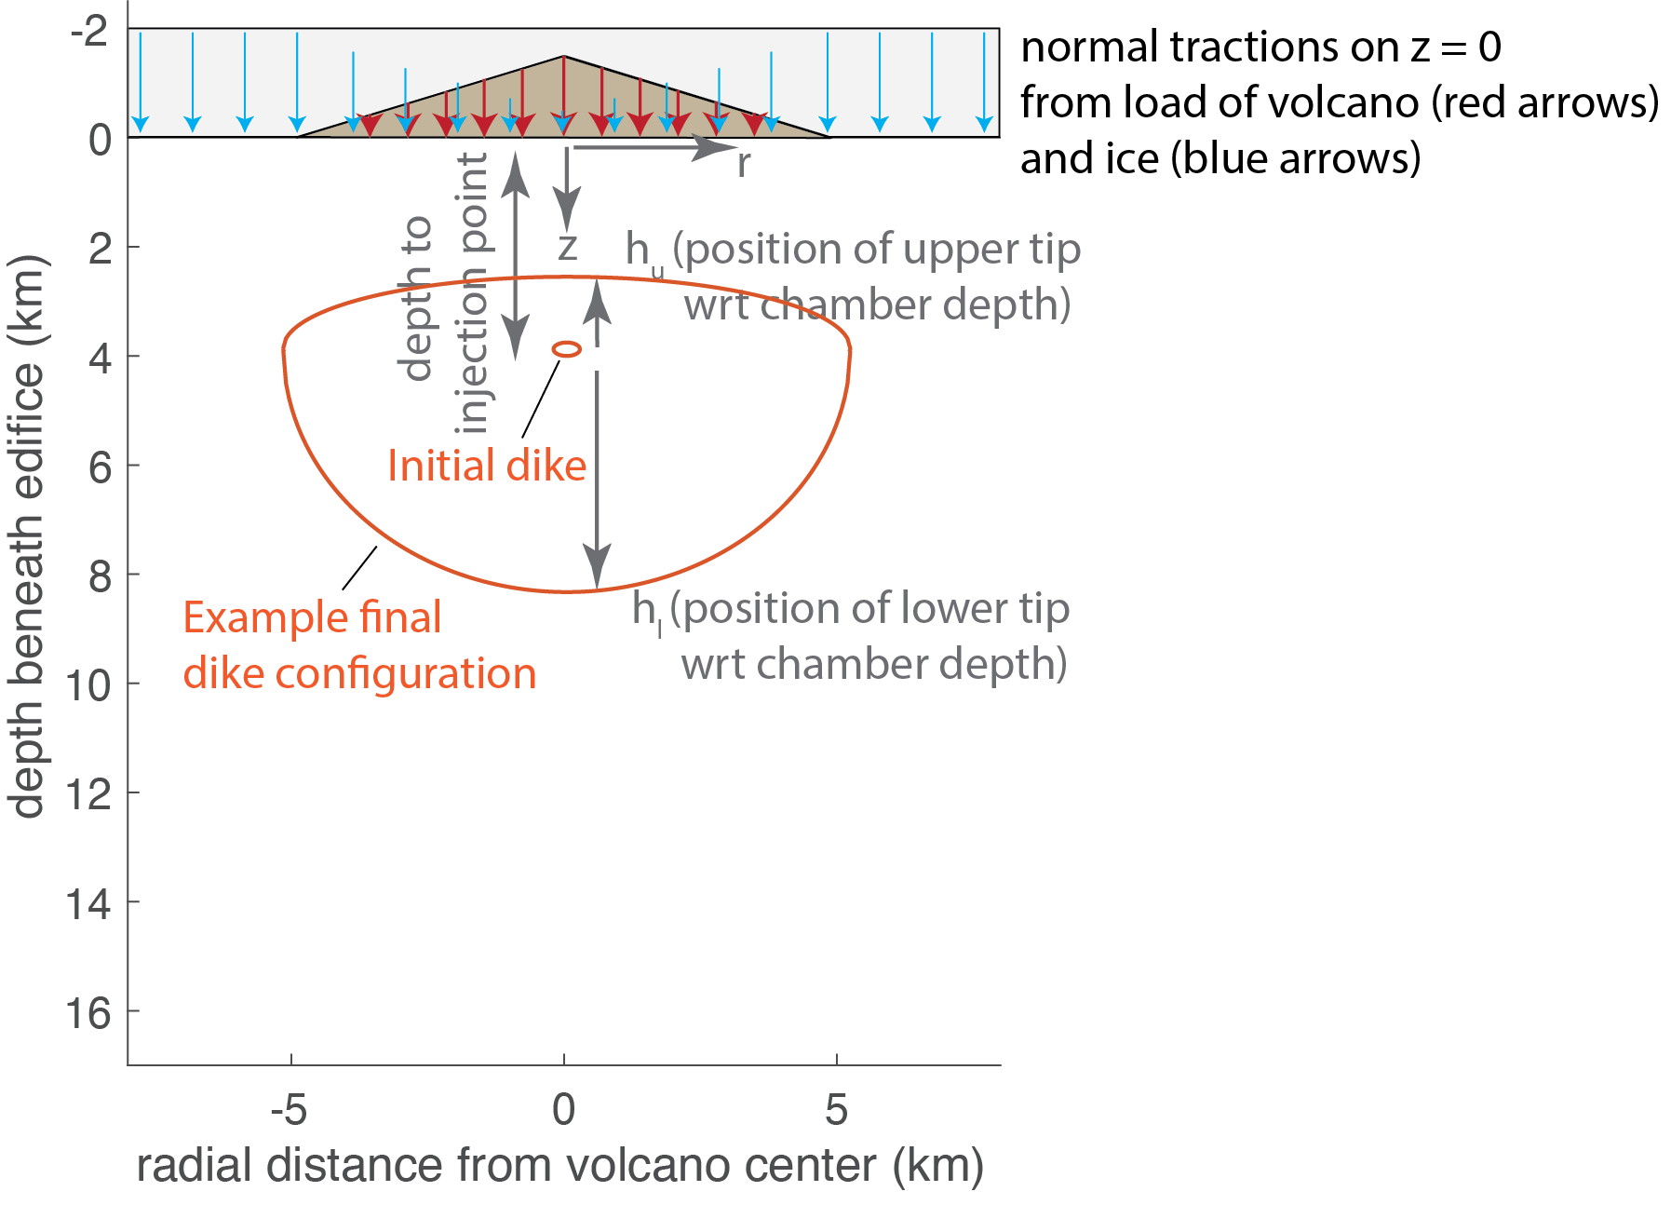
Schematic of Model B: blue and red arrows represent normal tractions acting on the crust as a result of the ice and volcano load; red ellipses are examples of initial and final dike configurations, with arrows and symbols defining the key variables.

Equations:

The volume of the dike is the sum of the volume of the upper and lower half-ellipsoids $V_{d}=\frac{π}{3}aδ(h_{u}+h_{l})$, but because we can define the total half-height $b=\frac{1}{2}\left(h_{u}+h_{l}\right)$, $V_{d}=\frac{2π}{3}abδ$ and we have the same equations as Model A, except we can set $\frac{dP_{con}}{dt}=0$ and just solve for dike excess pressure at the inlet ${ΔP}_{d}$ because the injection point is fixed:

$$\frac{dh_{u}}{dt}≅\frac{δ^{2}}{3η}\left(\frac{ΔP_{d}}{b}+{\left.\frac{dσ}{dz}\right|}_{z={d_{i}-h}_{u}}-ρ_{m}g\right)$$
$$\frac{dh_{l}}{dt}≅\frac{δ^{2}}{3η}\left(\frac{ΔP_{d}}{b}-{\left.\frac{dσ}{dz}\right|}_{z={d_{i}+h}_{l}}+ρ_{m}g\right)$$
$$\frac{db}{dt}=\frac{1}{2}\left(\frac{{dh}_{u}}{dt}+\frac{{dh}_{l}}{dt}\right)$$
$$\frac{da}{dt}≅\frac{δ^{2}}{3η}\left(\frac{ΔP_{d}}{a}+{\left.\frac{dσ}{dr}\right|}_{r=a}\right)$$
$$\frac{d{ΔP}_{d}}{dt}≅\frac{3μE\left(k\right)}{4π\left(1-ν\right)ab^{2}}\left(q_{in}-q_{erupt}\right)-\left[1-A\right]\frac{ΔP_{d}}{a}\frac{da}{dt}-\left[2+A\right]\frac{ΔP_{d}}{b}\frac{db}{dt}$$

Initial conditions:
$h_{u}\left(0\right)=b(0)$
$h_{l}\left(0\right)=b(0)$
$a\left(0\right)=0.02*d_{i}$
$b\left(0\right)=a\left(0\right)/2$
$$V_{d}\left(0\right)=0$$
${ΔP}_{d}\left(0\right)=0$
$$P_{con}\left(0\right)=σ(z=d_{i})$$

Stopping conditions:
We stop the dike growth model when
- the final injection volume is reached
- when the dike breadth reaches some critical value
- when the dike excess pressure goes to zero, or
- when the upper or lower tip moves past the point of injection
and/or when the simulation reaches some maximum time.

MODEL C: NON-ELLIPTICAL DIKE, FIXED INLET, CONSTANT EXCESS PRESSURE

Code location:

/Users/mtownse4/Dropbox (Lehigh University)/All Dropbox Files/Matlab/Volcano Loading/DIKE MODEL WORK SUMMER 2024/MODEL C: NONELLIPTICAL DIKE FIXED INJECTION CONSTANT P

Description:
-rationale: forcing the dike to be an ellipsoid is not consistent with observations from gelatin experiments and does not let us test where the dike will be able to ascend into the edifice and/or erupt
-unfortunately, it’s too hard to compute the volume of a non-elliptical dike (I mean technically there are ways but they involve discretizing the dike and computing the opening on each patch using something like Okada… this would be computationally more expensive), which means conservation of volume is not a good way to go here
-instead, let’s just prescribe a constant excess pressure at the dike inlet and track the velocity of observations points moving radially away from the injection site
-for comparison with gelatin experiments, there will have to be some calibration of what this constant excess pressure is

Equations:

This is a purely kinematic model where the velocity of the observation points is

$$v(r,θ)≅\frac{δ^{2}}{3η}\left(\frac{ΔP_{d}}{r}+{\left.\frac{dσ}{dr}\right|}_{r,θ}+g(ρ_{r}-ρ_{m})sinθ\right)$$
Where $ΔP_{d}$ is the constant excess pressure at the dike injection point, $r$ is the radial distance between the observation point at the injection point, $σ$ is the perturbation to the lithostatic stress field, and $θ$ is the angle of the observation point from zero (see cartoon). The observation points are advanced at each timestep by a distance of $v*dt$.

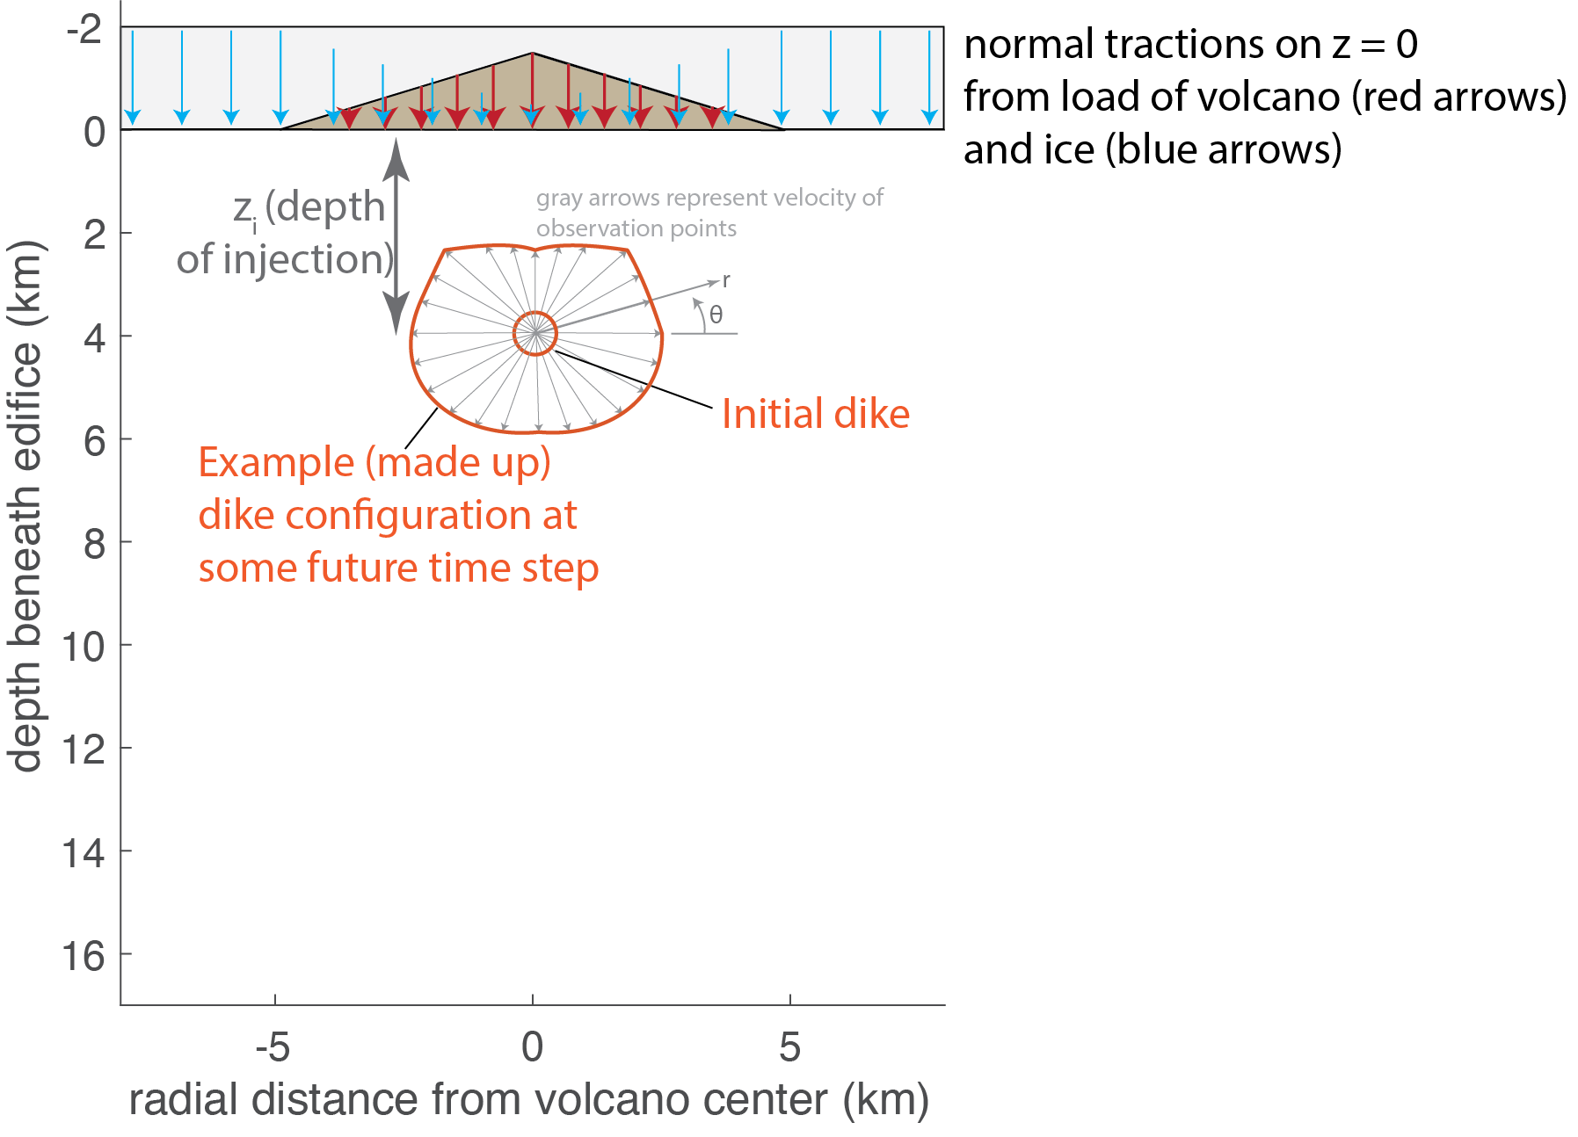

Initial conditions:

Stopping conditions:

-stops if observation points intersect base of edifice (still need to compute stress gradient in edifice if we want to consider that)

